**ONLINE BIKE RENTAL SYSTEM**

**A Project Report submitted in partial fulfillment of the requirement for the award of**

**Bachelor of Science in**

**Computer Science**

**of Bharathiar University, Coimbatore-46.**

**by**

**BISMIYA ASHARAF**

**Reg. No: 2122K1325**

**Under the guidance of**

**Dr. Priya.R MCA., M.Phil., Ph.D., Associate Professor & Head**

**Department of Computer Science**



**SREE NARAYANA GURU COLLEGE**

**K.G.CHAVADI, COIMBATORE –641105.**

**(Affiliated to Bharathiar University)**

**(Re-Accredited by NAAC & An ISO 9001-2015 Certified Institution)**

**March - 2024**

**ONLINE BIKE RENTAL SYSTEM**

**Bonafide Work Done by**

**BISMIYA ASHARAF**

**Reg. No: 2122K1325**

**Under the guidance of**

**Dr. Priya.R MCA., M.Phil., Ph.D., Associate Professor & Head**

**Department of Computer Science**

**A project report submitted in partial fulfillment of the requirements for the award of Bachelor of Science**

**in**

**Computer Science**

**of Bharathiar University**



**SREE NARAYANA GURU COLLEGE**

**(RE-ACCREDITED BY NAAC& AN ISO 9001-2015 CERTIFIEDINSTITUTION)**

**(Affiliated to Bharathiar University)**

**K.G.Chavadi,Coimbatore-641105**

**March-2024**

**ONLINE BIKE RENTAL SYSTEM**

**Bonafide Work Done by**

**BISMIYA ASHARAF**

**Reg. No: 2122K1325**

**Under the guidance of**

**Dr. Priya.R MCA., M.Phil., Ph.D., Associate Professor & Head**

**Department of Computer Science**

**A project report submitted in partial fulfillment of the requirements for the award of**

**BACHELOR OF SCIENCE**

**in**

**COMPUTER SCIENCE**

**of Bharathiar University, Coimbatore-105.**



**Guide HOD**

**Submitted for the viva voice examination held on ………………….**

**Internal Examiner External Examiner**

**DECLARATION**

I, **BISMIYA ASHARAF** here by declaring that the project report entitles as

“**ONLINE BIKE RENTAL SYSTEM”** done as the partial fulfillment of the requirement for the degree of Bachelor of Science in Computer Science is an independent project report done by me during the project duration of my period of study in **Sree Narayana Guru College**, K.G. Chavadi, Coimbatore under the guidance of **Priya.R MCA., M.Phil., Ph.D.,** Associate Professor & Head, Department of Computer Science.

|  |  |
| --- | --- |
| **Signature of the Guide** | **Signature of the Student** |

**BISMIYA ASHARAF**

**ACKNOWLEDGEMENT**

**CONTENTS**

**SYNOPSIS**

**Page No**

1. **INTRODUCTION 1** 
   1. **ORGANIZATION PROFILE 2**
   2. **SYSTEM SPECIFICATION 3** 
      1. **HARDWARE CONFIGURATION 3**
      2. **SOFTWARE SPECIFICATION 3**
2. **SYSTEM STUDY 11** 
   1. **EXISTING SYSTEM 12**
      1. **DRAWBACKS 12**
   2. **PROPOSED SYSTEM 13**
      1. **FEATURES 13**
3. **SYSTEM DESIGN AND DEVELOPMENT 14** 
   1. **FILE DESIGN 16**
   2. **INPUT DESIGN 16**
   3. **OUTPUT DESIGN 18**
   4. **DATABASE DESIGN 18**
   5. **SYSTEM DEVELOPMENT 19** 
      1. **DESCRIPTION OF MODULES 19**
4. **TESTING AND IMPLEMENTATION 21**
5. **CONCLUSION 28**

**BIBLIOGRAPHY 30**

**APPENDICES 32**

* + - 1. **DATA FLOW DIAGRAM 33**
      2. **TABLE STRUCTURE 36**
      3. **SAMPLE CODING 38**
      4. **SAMPLE INPUT 43**
      5. **SAMPLE OUTPUT 44**

# ACKNOWLEDGEMENT

# 

## ACKNOWLEDGEMENT

First and foremost, I express my sincere thanks to our beloved and

respected Principal **Dr Kalpana D.M.Com., B.Ed., M.Phil., Ph.D.,** Sree Narayana Guru

College , K.G Chavadi ,Coimbatore.

I would like to take this opportunity to express my sincere thanks to my project guide

Dr. **Priya. R MCA., M.Phil., Ph.D.,** Associate Professor & Head Department of Computer

Science, Sree Narayana Guru College, for valuable guidance, encouragement and helping

me to do the project work.

I would like to express my heartfelt gratitude to all the Staff members of our department,

Sree Narayana Guru College, K.G Chavadi, Coimbatore.

I would like to express my special thanks to my family and my friends who gave their

assistance at each and every stage of this project.

**SYNOPSIS**

## SYNOPSIS

The “**Online Bike Rental System”** is a web-based application developed using PHP and MySQL

to facilitate the efficient and convenient renting of bikes. The Users can easily browse through the

available bikes, view details and select the desired one for rent. The system is allows users to the

register, log in and manage their profiles. It incorporates secure the payment gateway in seamless

transactions. Admin functionalities include bike management, user monitoring and the reservation

tracking. The MySQL database is utilized to store and retrieve information, ensuring data integrity

and reliability. This simple yet effective online bike rental system streamlines the rental process,

providing a user-friendly interface for both customers and administrators.

## INTRODUCTION

This project is designed so as to be used by Bike Rental Company specializing in renting bikes to customers. It is an online system through which customers can view available bikes, register, view profiles and book bikes. The advancement in Information Technology and internet penetration has greatly enhanced various business processes and communication between companies, service providers and their customers of which the bike rental industry is not left out. This online bike Rental system is developed to provide the following services• Enhance Business Processes To be able to use internet technology to project the rental company to the global world instead of limiting their services to their local domain alone, thus increase their return on investment.

Key Features:

**Bike Selection**: Bike On Go offers a diverse selection of bicycles, from traditional road bikes to electric bikes with various speed and range options. Users can choose the bike that best suits their needs.

**User Registration and Profile Management**: Users can create an account, provide their information and manage their profiles. This information includes contact details and preferred payment methods.

**Bike Booking:** Users can easily browse available bikes, check their availability and make reservations for specific dates and times. Our platform ensures a seamless and secure booking process.

**Location-Based Services**: Bike On Go's mobile app offers a map with bike stations and real time information on bike availability. Users can quickly locate the nearest pickup and drop-off points.

**Payment Integration**: It support various payment methods, including credit/debit cards, digital wallets, and other secure payment options for hassle-free transactions.

**1.1 ORGANIZATION PROFILE**

**Sree Narayana Guru College**

With a view of imparting quality education for the aspiring youth of Coimbatore, Sree

Narayana Guru Educational Trust members came forward with a plan to start a college for Applied Sciences and Management Studies. Sree Narayana Guru College (SNGC) came into existence in 1994, Affiliated to Bharathiar University, Accredited by NAAC and Approved by Govt.of Tamilnadu.

Sree Narayana Guru College strives to emerge as a premiere institute of international standards promoting excellence and equity in higher education. To mould the students of the institution through a socially committed, intellectually inclined, value based and culture driven paradigms of learning using the state-of-the-art educational technologies.

* To enhance the learning capacity and knowledge of the students by imparting quality education of national and international standards.
* To make the students think critically, objectively, creatively and to be life-long learners, engaged leaders and productive citizens.
* To motivate the students to pursue research, to advance knowledge and to address the state, national and global challenges.
* To mould their character and develop a value system so as to manifest oneness among students of diverse socio-cultural and economic backgrounds.
* To identify the inherent talents of the students and provide a platform to exhibit them.

### 1.2 SYSTEM SPECIFICATION

**1.2.1 HARDWARE CONFIGURATION:**

|  |  |  |
| --- | --- | --- |
| Processor | : | AMD RYZEN. |
| RAM | : | 4GB |
| Hard disk | : | 500GB. |
| DVD writer | : | LG DVD writer. |
| Key Board | : | 110 keys. |

**1.2.2 SOFTWARE SPECIFICATION:**

Operating system : Windows 11

Front End Software : Php

Back End Software : Mysql

**SOFTWARE FEATURES**

**About Php**

PHP is an open-source, interpreted, and object-oriented scripting language that can be executed at the server-side. PHP is well suited for web development. Therefore, it is used to develop web applications (an application that executes on the server and generates the dynamic page.).

PHP was created by **Rasmus Lerdorf in 1994** but appeared in the market in 1995. **PHP 7.4.0** is the latest version of PHP, which was released on **28 November**. Some important points need to be noticed about PHP are as followed:

* PHP stands for Hypertext Preprocessor. o PHP is an interpreted language, i.e., there is no need for compilation. o PHP is faster than other scripting languages, for example, ASP and JSP.
* PHP is a server-side scripting language, which is used to manage the dynamic content of the website.
* PHP can be embedded into HTML. o PHP is an object-oriented language.
* PHP is an open-source scripting language. o PHP is simple and easy to learn language.

Why use PHP

PHP is a server-side scripting language, which is used to design the dynamic web applications

with MySQL database.

* It handles dynamic content, database as well as session tracking for the website.
* You can create sessions in PHP.
* It can access cookies variable and also set cookies.

o It helps to encrypt the data and apply validation.

PHP supports several protocols such as HTTP, POP3, SNMP, LDAP, IMAP, and many more.

o Using PHP language, you can control the user to access some pages of your website.

* As PHP is easy to install and set up, this is the main reason why PHP is the best language to learn.
* PHP can handle the forms, such as - collect the data from users using forms, save it into the database, and return useful information to the user. **For example** - Registration form.

**PHP Features**

PHP is very popular language because of its simplicity and open source. There are some important features of PHP given below:

**Performance:**

PHP script is executed much faster than those scripts which are written in other languages such as JSP and ASP. PHP uses its own memory, so the server workload and loading time is automatically reduced, which results in faster processing speed and better performance.

**Open Source:**

PHP source code and software are freely available on the web. You can develop all the versions of PHP according to your requirement without paying any cost. All its components are free to download and use.

**Familiarity with syntax:**

PHP has easily understandable syntax. Programmers are comfortable coding with it.

**Embedded:**

PHP code can be easily embedded within HTML tags and script.

**Platform Independent:**

PHP is available for WINDOWS, MAC, LINUX & UNIX operating system. A PHP application developed in one OS can be easily executed in other OS also.

**Database Support:**

PHP supports all the leading databases such as MySQL, SQLite, ODBC, etc.

**Error Reporting -**

PHP has predefined error reporting constants to generate an error notice or warning at runtime. E.g., E_ERROR, E_WARNING, E_STRICT, E_PARSE.

**Loosely Typed Language:**

PHP allows us to use a variable without declaring its datatype. It will be taken automatically at the time of execution based on the type of data it contains on its value.

**Web servers Support:**

PHP is compatible with almost all local servers used today like Apache, Netscape, Microsoft IIS, etc.

**Security:**

PHP is a secure language to develop the website. It consists of multiple layers of security to prevent threads and malicious attacks.

**Control:**

Different programming languages require long script or code, whereas PHP can do the same work in a few lines of code. It has maximum control over the websites like you can make changes easily whenever you want.

**A Helpful PHP Community:**

It has a large community of developers who regularly updates documentation, tutorials, online help, and FAQs. Learning PHP from the communities is one of the significant benefits.

**Mysql**

**MySQL**

MySQL is an open-source relational database management system (RDBMS) that plays a crucial role in handling and organizing data for various applications. As part of the LAMP stack, MySQL is particularly popular in web development. Operating under the GNU General Public License, it is freely accessible, making it a cost-effective choice. Following the principles of a relational database, MySQL employs the Structured Query Language (SQL) for database interaction. Its cross-platform compatibility, supporting Linux, Windows, and macOS, contributes to its widespread adoption. Recognized for scalability, MySQL efficiently manages databases of varying sizes, making it suitable for both small projects and large-scale applications. With robust security features, including user authentication, encryption, and access control, MySQL ensures the protection of stored data. The active and expansive community surrounding MySQL provides valuable support through forums and online resources. Offering multiple storage engines, replication capabilities, and support for triggers and stored procedures, MySQL remains a versatile and reliable solution for diverse database needs.. MySQL supports many Operating Systems like Windows, Linux, MacOS, etc. with C, C++, and Java languages.

MySQL is a Relational Database Management System (RDBMS) software that provides many things, which are as follows:

o It allows us to implement database operations on tables, rows, columns, and indexes.

o It defines the database relationship in the form of tables (collection of rows and columns), also known as relations.

OIt provides the Referential Integrity between rows or columns of various tables.

o It allows us to updates the table indexes automatically.

##### **Special Features of MySQL**

MySQL, as a powerful relational database management system, boasts several features that contribute to its widespread use. Here are five key features of MySQL:

1. Open Source: MySQL is an open-source database system, available under the GNU General Public License (GPL). This characteristic allows users to freely download, use, and modify the software's source code, fostering a collaborative community and making it cost-effective for various applications.
2. Scalability: MySQL is known for its scalability, allowing it to efficiently handle databases ranging from small to large-scale enterprise systems. This feature makes it adaptable to the evolving needs of applications and organizations as they grow over time.
3. Cross-Platform Compatibility: MySQL is designed to run on multiple operating systems, including Linux, Windows, and macOS. This cross-platform compatibility ensures flexibility in deployment and facilitates integration into diverse technology stacks.
4. Security Features: MySQL incorporates robust security features to safeguard data integrity and confidentiality. It includes mechanisms for user authentication, encryption, and access control. Database administrators can control user permissions and restrict access to sensitive information, enhancing overall data protection.
5. Replication: MySQL supports replication, allowing the duplication of data across multiple database servers. This feature is beneficial for achieving high availability, load balancing, and disaster recovery. Replication in MySQL can be configured in various ways to meet specific requirements, enhancing the reliability and performance of database systems.

**WINDOWS 11**

As of my last knowledge update in January 2022, Windows 11 was the

Latest operating system released by Microsoft. Introduced in June 2021,

Windows11 brought a fresh and modernized user interface compared to

it predecessor, Windows 10. The update featured centered a Start Menu,

a redesigned taskbar and improvements to window management with a

features like Snap Layouts a and Snap Groups. Additionally, Windows

11 included new Widgets feature for personalized at-a-glance with the

information, integration of a Microsoft Teams in to the taskbar and the

enhancements in a gaming features like Direct Storage and Auto HDR.

The Microsoft Store is received a makeover, offering an amore user-

friendly experience and broader app support. However, it's important

to note that developments may have occurred since my last update and

should refer to the official Microsoft website or other reliable sources

for the latest information on Windows 11.

**Redesigned Start Menu and Taskbar:**

* Windows 11 features a centered Start Menu and Taskbar, giving the interface a more streamlined and modern look.
* The Start Menu includes a simplified design with Live Tiles removed in favor or a grid of static icons.

**Snap Layouts and Snap Groups:**

* Windows 11 introduced new window management features called the Snap Layouts and Snap Groups.
* Snap Layouts allow users to quickly organize and snap open windows into predefined layouts, making multitasking more efficient.
* Snap Groups enable users to switch between groups of apps and open

windows associated with specific tasks or projects.

**Microsoft Store Redesign:**

* The Microsoft Store in Windows 11 underwent a significant redesign, offering a cleaner and more user-friendly interface.
* The new Store features a wider range of apps, including support for both traditional Win32 apps and Universal Windows Platform (UWP) apps.
* Microsoft also introduced a new revenue-sharing model for app the developers.

**Direct integration with Microsoft Teams:**

* Windows 11 integrates Microsoft Teams directly into the taskbar, to making It easier for users to access and use the collaboration tool for

video calls, messaging and meetings.

hence are just a few highlights, and Windows 11 includes various others improvement in performance, security and user experience compared to

its predecessors. Keep in mind that developments may have occurred in

since my last update, and it's advisable to check the official Microsoft is a

website or other reliable sources for the latest information on Windows 11.

**SYSTEM STUDY**

## SYSTEM STUDY

**EXISTING SYSTEM**

Bike Rental System service will help users to book a bike for some fee specified.

Till now There was no clear web based UI to help the users to rent the vehicle. They

had to manually rent the vehicle through their offices. It was difficult task to manage

rental vehicles. Keeping track of all the rental bikes was a problem.

**2.1.1 DRAWBACKS**

A bike rental system typically includes various features to ensure efficient management and user-friendly experience. Here are some key points regarding the features of a bike rental system:

* Limited availability and accessibility.
* Quality and maintenance.
* Security concerns.
* User responsibility.
* Technology dependency.
* Regulatory challenges.

• Environmental impact.

* Cost and pricing structure.

**2.2 PROPOSED SYSTEM**

This Bike Rental System project will enable the user to rent a

vehicle. user shall login to the system and check for availability of bikes.

The user to specifies type of bike and the journey date and time. The Bike

Rental System shall check for the availability of the bike and rent the bike

to the customer. The user can make payment online. The tool is designed

using PHP. All the data in regarding the rental bikes are stored in MySQL

database. The user has to enter name, address, phone no details and check

for the bikes available for rent. The UI is very simple and the can a be an

connectivity to back end is robust. The main advantage is that the user shall

be an able to choose a bike depending on the budget.

**2.2.1 FEATURES**

* **User Registration and Authentication:**
  + - Allow users to create accounts securely with email verification.
    - Implement social media login options for convenience.
* **Search and Booking:**
  + - Provide a user-friendly interface for searching and browsing available bikes.
    - Include filters for bike type, location, availability and features.
* **Geolocation Services:**
  + - Implement GPS integration to help users find nearby bike stations.
    - Provide map-based navigation for users to locate bikes easily.
* **Bike Details and Images:**
  + - Display comprehensive information about each bike, including model, type, features and condition.
    - Include high-quality images of each bike for users to preview.
* **Reservation Management:**
  + - Send reservation confirmation notifications via email or SMS.
    - Allow users to modify or cancel reservations within a reasonable time frame.

### SYSTEM DESIGN AND DEVELOPMENT

**3. SYSTEM DESIGN AND DEVELOPMENT**

The proposed system design for an online bike rental system encompasses a user-centric approach, ensuring a seamless and secure experience. The user interface features an intuitive booking platform, allowing users to effortlessly search for available bikes based on their preferences and location. A robust geolocation service, integrated with maps and geofencing, assists users in identifying nearby bike stations and defines service areas. The booking process is streamlined, with real-time availability updates, quick booking options, and transparent pricing displayed to users. Secure payment gateways support various transaction methods, prioritizing the safety of financial information. User profiles and history functionality contribute to personalization, enabling users to manage their preferences and review past rentals. A comprehensive notification system ensures timely communication, from reservation alerts to reminders and promotional notifications. The system design also incorporates an efficient admin dashboard, equipped with tools for inventory management, analytics, and user support, ensuring smooth operations and data-driven decision making. This holistic design not only prioritizes user experience but also addresses key operational aspects to create a reliable and user-friendly online bike rental platform.

**FILE DESIGN**

The PHP and MySQL-based bike rental system follows a well-structured file design

to maintain a modular and organized codebase. The system typically comprises various

files and directories “including "config" folder housing database configuration files to

establish a connection with MySQL. The "includes" directory holds reusable PHP is a

components like headers, footers and to navigation menus, promoting code a reuse and

maintainability. The are "models" directory encapsulates PHP classes responsible for a

interacting with the MySQL is a database, handling data operations related bikes, users,

rentals, and other essential entities. The "views" directory consists of PHP files to be a

representing different pages or views, ensuring clear a separation of the concerns. The

"controllers" directory contains PHP files responsible for the processing user input, in a

interacting with the models, and rendering the appropriate views. the Additionally, are

there might be a "utils" directory for utility functions and a "public" directory for CSS,

JavaScript, and other publicly accessible assets. This file a structure enhances the code

organization, promotes reusability, and facilitates collaboration among developers to a

working on different aspects of the bike rental system.

**INPUT DESIGN**

In the context of an online bike rental system implemented in PHP, the input

Design is crucial to ensure user-friendly interactions and prevent the security

vulnerabilities. Here's a brief outline of a input design considerations:

1. **User Registration Form (register.php):**
   * information such as username, email, phone number, and password.
   * Implement client-side validation for password strength and email format.
2. **Login Form (login.php):**
   * Request user credentials, typically username/email and password.
   * Implement CAPTCHA or other anti-bot measures to enhance security.
3. **Bike Search and Booking Form (search.php, book.php):**
   * Design an intuitive interface for users to search and book bikes.
   * Include dropdowns, calendars, and radio buttons for location, date, and bike selection.
4. **Feedback and Rating Form (feedback.php):**
   * Create a form to gather user feedback and ratings for rented bikes.
   * Include text fields and rating scales for user comments and ratings.
5. **Profile Update Form (profile.php):**
   * Allow users to update their profile information, including contact details.
   * Use pre-filled form fields and validation to ensure accurate updates.
6. **File Upload Form (upload.php):**
   * Design a form for users to upload images, such as profile pictures or bike photos.
   * Include file type restrictions and size limits to prevent abuse.
7. **Reservation Modification Form (modify reservation.php):** 
   * Enable users to modify or cancel existing reservations.
   * Display current reservation details and provide options for changes.
8. **Payment Form (payment.php):**
   * Create a secure form for users to input payment details.
   * Utilize HTTPS and SSL for secure transactions.

By implementing these considerations, the input design in the online

bike rental ensures a user-friendly and secure experience, mitigating potential risks

associated with user interactions.

**3.3OUTPUT DESIGN**

The output design in the PHP and MySQL-based bike rental system is

meticulously crafted to provide an intuitive and engaging user experience. A web

pages are designed using HTML and the CSS to ensure an responsive and visually

appealing layout cross various devices. Dynamic content generated by PHP scripts

is seamlessly integrated with MySQL data to present real-time information such as

a available bikes, user details, and rental history. User interfaces are a thoughtfully

designed with they are consistent navigation to elements, ensuring ease of use and a

cohesive visual identity. Rental details, including bike specifications, rental duration

durations and pricing, are presented in a structured and easily to digestible format. In

Interactive elements, such as buttons and forms, are strategically place for a smooth

user journey, allowing customers to browse bikes, make reservations and manage a

their rental history effortlessly. Error message and notifications are designed to be a

informative and user-friendly, aiding in an seamless the interaction with the system.

In Overall output design of the bike rental system prioritizes clarity, responsiveness

and an visually pleasing aesthetic to enhance the of a overall user experience.

.

**DATABASE DESIGN**

The online bike rental system in php required a well-structured database

design to Efficiently an manage and organize the relevant information. The database will be

typyically consist of a several key tables, each serving a specific purpose. One fundamental

table is to "Bikes" table, containing details such as bike ID, model, type and availability status.

another essential table is the "Users" table, which stores information about customers,

including the user ID, name, contact details, and rental history. To facilitate the rental

process, be "Rentals" table is necessary, linking bike and user information, with the additional

fields like rental start and end dates.

Furthermore, a "Locations" table may be incorporated to manage the

availability of the bikes at different rental locations. This table could include location ID, name,

address and the number of available bikes. To enhance security, a "Login" table may be a they

implemented to store user credentials securely. It typically includes fields such as are user ID,

username, password and possibly additional security features. These tables is a interconnected

through relationships, ensuring data consistency and integrity. For the instance, of the Rentals

table could reference to the Bikes and Users tables establish connections between rented bikes

Overall, a well-designed database for an online bike rental system in PHP is crucial for seamless

operations, efficient data retrieval, and an positive user experience. The structure should support

essential functionalities such a bike availability tracking, user management, and rental history in

maintenance.

## SYSTEM DEVELOPMENT

**3.5 .1 DESCRIPTION OF MODULES**

The description module in an online bike rental system built with PHP is a crucial component that allows users to obtain a detailed information about the available bikes, facilitating an informed decision-making process. This module typically encompasses various features and functionalities to enhance the user experience. Here's a breakdown of the description module in an online bike rental system:

**Bike Information Display:**

* The module should display a comprehensive list of available bikes, including details such as model, type, features and specifications. Users can browse through this information to choose a bike that suits their preferences

and an requirements.

**High-Quality Images:**

* Incorporate high-quality images of each bike to provide users with a visual representation. This helps users assess the appearance and style of the bikes before making a selection.

**Pricing and Rental Terms:**

Clearly present the pricing structure for each bike, detailing rental rates, duration options and any additional fees. Include transparent information about security deposits and payment methods to ensure users are well-informed.

**Availability Status:**

* Indicate the real-time availability status of each bike. Users should easily see whether a particular bike is currently available for rent or if it's already booked for a specific period.

**User Reviews and Ratings:**

* Allow users to leave reviews and ratings for bikes they have rented in the past. This provides valuable insights for potential renters and enhances the trustworthiness of the rental platform.

**Related Biking Accessories:**

* If applicable, showcase related biking accessories that users can rent along with the bike, such as helmets, locks or GPS devices. This encourages users to consider additional items for a more convenient and enjoyable biking experience.

**Booking Options:**

* Include a user-friendly booking interface within the description module, enabling users to select their desired rental dates, add any extras and proceed with the reservation process seamlessly.

**Dynamic Updates:**

* Implement dynamic updates to reflect changes in availability, pricing, or other details in real-time. This ensures that users always have the latest and most accurate information when exploring the available bikes.

**Responsive Design:**

* Ensure the module is responsive and accessible on various devices, including smartphones, tablets and desktops. This guarantees a consistent and user-friendly experience across different platforms.

By incorporating these features into the description module, an online bike rental system in PHP can provide users with a comprehensive and engaging platform for exploring, selecting and booking bikes for their desired rental period.

**TESTING AND IMPLEMENTATION**

## 4. TESTING AND IMPLEMENTATION

**SYSTEM IMPLEMENTATION**

System testing for an online bike rental system is a crucial phase in the software

development life cycle, ensuring that the entire system functions seamlessly as an integrated

whole. This comprehensive testing process involves evaluating the system's performance in

against predefined requirements and specifications. The online bike rental system undergoes

rigorous assessments, including functional testing to validate the core functionalities such as

user registration, bike selection, reservation and payment processing. Additionally, system

testing encompasses non-functional aspects, such as performance testing to determine the in

system's responsiveness under varying loads and security testing to identify and address is a

vulnerabilities in data protection and user privacy. Usability testing is conducted to ensure in

that the user interface is intuitive and an user-friendly, promoting a positive customer are the

experience. Compatibility testing ensures that the system functions correctly across different

browsers and devices. Thorough system testing of the online bike rental platform helps identify

and rectify any issues before deployment, ensuring a reliable, secure and user-friendly service

for both rental operators and customers.

**SYSTEM TESTING**

System testing focuses verification effort on the smallest unit of software design of the module. Using the detail design description as a guide, important control paths are tested to uncover errors within the boundary of the module. The relative complexity of tests and the errors detected as a result is limited by the constrained scope established for unit testing. The unit is always white box- oriented and the step can be conducted in parallel for multiple modules. System testing is normally considered an adjunct to the coding step. After source level code has been developed, reviewed and verified for correct syntax, unit test case design begins.

A review of design information provides guidance for establishing test cases that are likely to uncover errors in each of the categories discussed above. Each test case should be coupled with a set of expected results.

Because a module is not a stand-alone program, driver and / or stub software must be developed for each system test. In most applications a driver is nothing more than a “main program” that accepts test case data, passes such data to the module and prints the relevant results. Stubs serve to replace modules that are subordinates (called by) the module to be tested.

**WHITE BOX TESTING**

In this approach of testing, tests are made with the complete knowledge about the internal working of the product. Tests can be conducted to ensure that all the internal operations of the product perform according to the specifications and all the internal components have been adequately tested. Check points at various places could be placed, so that checks are made to see if the status corresponding to the actual status.

Test cases designed through this approach ensure that

All independent paths within a module have been exercised at least once, executing all logical decisions depending on their true or false values.

• Execute all loops well within their bounds • Exercise internal data structure to ensure their validity etc.

**BLACK BOX TESTING**

In this approach to testing, test cases are prepared with the knowledge about the function that the product is designed to perform. Tests can be conducted which demonstrates the complete functionality of the product. Tests are done to check if the product is fully operational rather than checking each loops are conditions of the function. At the software level of testing, this approach resolves around testing the software interface. This approach has very little regard for the internal logical structure of the software. This approach saves time and energy.

Although this approach of testing is designed to uncover errors, they demonstrate that the functions are fully operational. They ensure that the inputs are properly accepted and desired output is obtained. They also provide for maintaining the complete integrity of the external input.

The attributes of both black and white box testing can be combined to provide an approach that validates the software interfaces and selectively ensures that the internal workings of the software are correct.

**UNIT TESTING**

Unit testing focuses verification effort on the smallest unit of software design, module. This testing was carried out during the coding itself. In this testing step, each module is found to be working satisfactorily as per the expected output from the module.

**SYSTEM TESTING**

The next level of testing is system testing where the system analyst tests all of the components to see that they interact correctly when combined as a system. A series of testing are performed for the newly developed system before the system is ready for user acceptance testing.

**VALIDATION TESTING**

Validation succeeds when the software functions in a manner that is reasonably expected by the customer. Software validation is achieved through a series of black box test that demonstrate conformity with the requirements. Deviations or errors at this step are corrected.

**OUTPUT TESTING**

The output generated by the system under consideration is in the format required by the user and the information in the reports is accurate. It is possible to generate timely reports without any errors.

**USER ACCEPTANCE TESTING**

User acceptance of a system is a key factor for the success of any system. The system under consideration was tested for user acceptance by constantly keeping in touch with prospective system users at the time of developing and making changes wherever required.

### PERFORMANCE TESTING

Performance testing is a testing measure that evaluates the speed, responsiveness and

stability of a computer, network, software program or device under a workload. Organizations

will run performance tests to identify performance-related bottlenecks.

**REGRESSION TESTING**

Regression Testing is a type of testing in the software development cycle that runs

after every change to ensure that the change introduces no unintended breaks. The Regression

testing addresses a common issue that developers face — the emergence of old bugs with the introduction of new changes.

**SECURITY TESTING**

Security testing involves verifying the software's compliance with security

standards, to evaluating the security features and mechanisms, and conducting they

penetration tests to identify weaknesses and vulnerabilities that might be exploited

by malicious actors.

**SYSTEM MAINTENANCE**

System maintenance is widely accepted part of SDLC now a days. It stands for all modifications and a updation done after the delivery of software product. Software maintenance is far more than finding mistakes. Provision must be made for product a environment changes, which may an affect either the computer, or other parts of the computer based systems. Such activity is normally called maintenance. It includes both the improvement of the system functions and the corrections of faults, which arise during the operation of a new system. It may involve the continuing files of a involvement of large proportion of computer department recourses. The main task

may be to adapt existing systems in changing environment. Back up for the entire database files are taken and stored in storage devices like flash drives, pen drives a

and disks so that it is possible to restore the system at the earliest. If there is an the breakdown or collapse, then the system gives provision to restore database files.an storing data in a separate secondary device leads to an a effective and efficient an a maintains of the system. The nominated of a person has sufficient knowledge of the organization’s computer passed based on a system to be able to judge the relevance

of each proposed change.

There are number of reasons, why modifications are required, some of them are briefly mentioned below:

**Market Conditions** - Policies, which changes over the time, such as taxation and newly introduced constraints like, how to maintain bookkeeping, may trigger need for modification.

**Client Requirements** - Over the time, customer may ask for new features or functions in the software.

**Host Modifications** - If any of the hardware and/or platform (such as operating system) of target the host changes, software changes are needed to keep adaptability.

**Organization Changes** - If there is any business level change at client end, such as reduction of organization strength, acquiring another company, organization venturing into new business, need to modify in the original software may arise.

**TYPES OF MAINTENANCE**

In a software lifetime, type of maintenance may vary based on its nature. It may be just a routine maintenance tasks as some bug discovered by some user or it may be large event in itself based on maintenance size or nature. Following are some types of maintenance based on their characteristics:

**Corrective Maintenance** - This includes modifications and updation done in order to corrector fix problems, which are either discovered by user or concluded by user error reports.

**Adaptive Maintenance** - This includes modifications and updation applied to keep the software product up-to date and tuned to the ever changing world of technology and business environment.

P**erfective Maintenance** - This includes modifications and updates done in order to keep the software usable over long period of time. It includes new features, new user requirements for refining the software and improve its reliability and performance.

**Preventive Maintenance** - This includes modifications and updation to prevent future problems of the software. It aims to attend problems, which are not significant at this moment but may cause serious issues in future.

## CONCLUSION

**5. CONCLUSION**

This Project is minimizing the task of parking a vehicle by paying and saying some details about vehicle to save data. This application will help user to park the vehicle safe and secure, the created application is been try out with sample inputs and outputs in according to the requirement. The regulation of the developed system can be increase with some minor modifications. Future development can be made in proposed system by integration more services like: It can be implemented through web pages. New effective’s modules can be added according to updates time to time. Since we are entering details of the parking Places electronically in the “Online Parking Management System”, data will be secured. Using this application we can Easily Get Information on parking places and our previous parking history with a single click. Thus processing information will be faster. It guarantees accurate maintenance of Parking details. It easily reduces the book keeping task and thus reduces the human effort and increases accuracy speed.

.

**BIBLIOGRAPHY**

## BIBLIOGRAPHY

**REFERENCE BOOKS**

* PHP6 and MySQL6 Bible – Steve Svehring.
* PHP Programming Solutions – Vickram Viswani.
* Web development and application development by Ivan Byross BPB publications.

**WEBSITE:**

* https://www.youtube.com/@tj_webdev
* http://www.w3schools.com/html/html_intro.asp
* https://www.w3schools.com/php/default.asp
* https://www.w3schools.com/sql/default.asp

**APPENDICES**

## A. DATA FLOW DIAGRAM

Data Flow Diagram (DFD) representing a system at any level of detail with a graphic network of symbols showing data flows, data stores, data processes, to and data sources. The purpose of DFD is to provide a semantic bridge between users and system developers. The diagram is the basis of structured system analysis. A level 0 DFD, also called a fundamental system model or context model represents the entire software elements as a single bubble with input and output indicated by incoming and outgoing arrows respectively. Additional the process and a information flow parts are represented in the next level i.e., Level 1 DFD. Each of the processes represented at a Level are sub functions of overall system depicted in a context model. Any processes, which are complex in Level 1, will be a further represented into sub functions into the next level, i.e., in level 2 Data flow diagrams are illustrate how data is processed by a system in terms of inputs and outputs. Represent major components or functions with Circles.

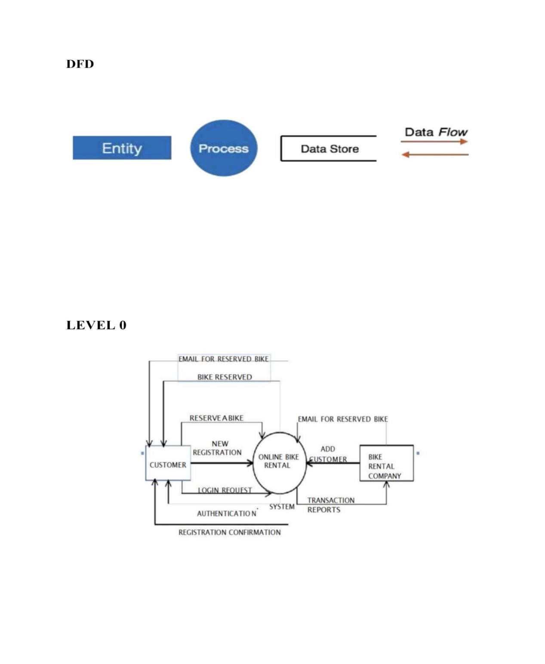

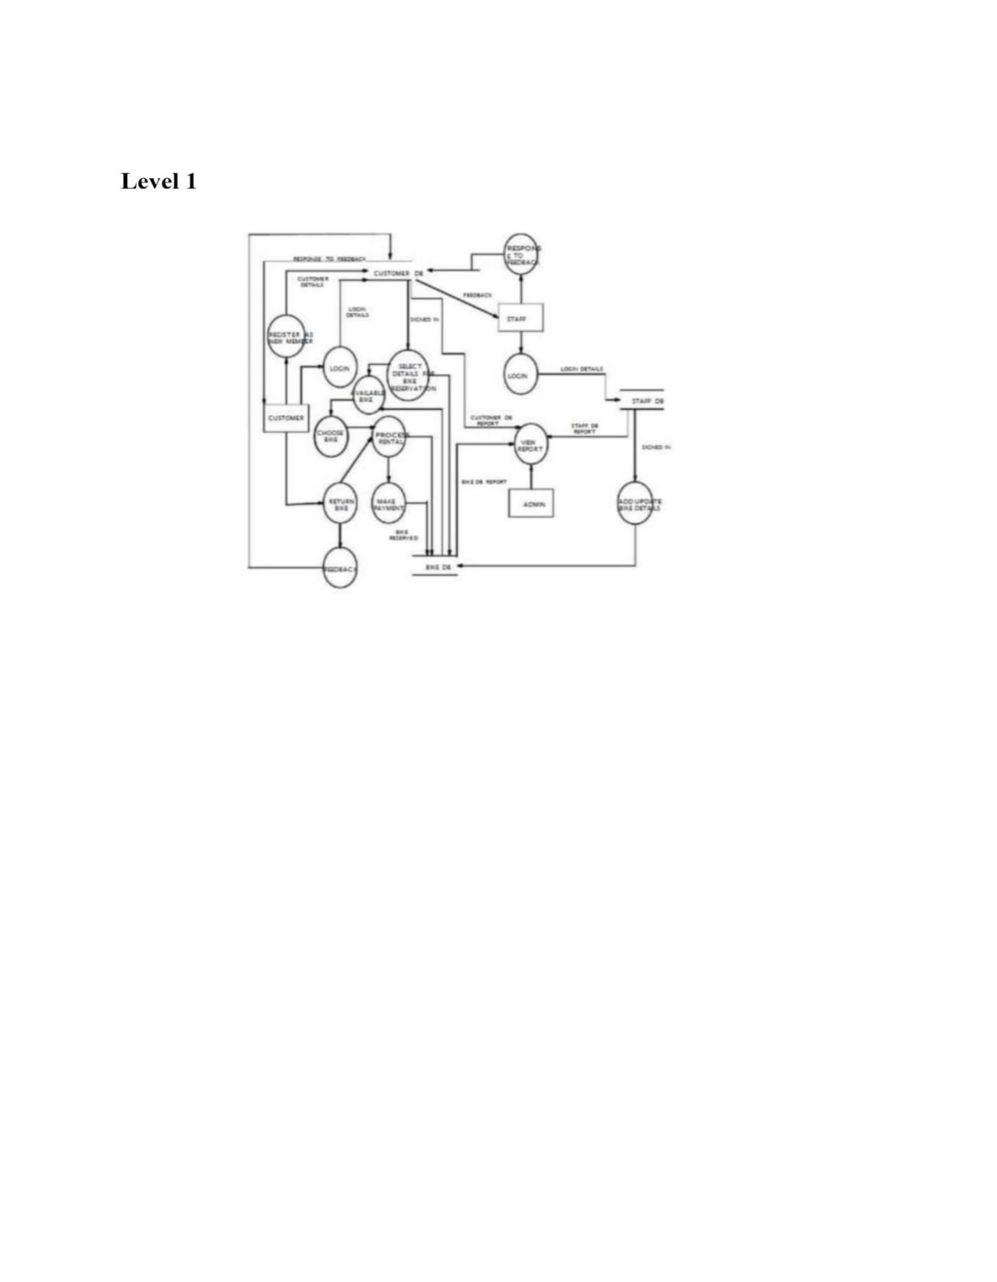

**B.TABLE STRUCTURE**

**1.Admin**

|  |  |  |  |
| --- | --- | --- | --- |
| **Field Name** | **Type** | **Constraints** | **Description** |
| Email | Varchar(50) |  | Email |
| Password | Varchar(10) |  | Password |

**2. User**

|  |  |  |  |
| --- | --- | --- | --- |
| **Field Name** | **Type** | **Constraints** | **Description** |
| U_id | Int(5) | Primary key | User Id |
| F_name | Char(30) |  | Customer Name |
| L_Number | Varchar(10) |  | Phone Number |
| Bike | Char(10) |  | Bike |
| Email | Varchar(30) |  | Email |
| Password | Varchar(8) |  | Password |

**3. Bike**

|  |  |  |  |
| --- | --- | --- | --- |
| **Field Name** | **Type** | **Constaints** | **Description** |
| Bike_id | Int(5) | Primary key | Bike id |
| Bike_name | Varchar(250) |  | Bike name |
| Bike_type | Varchar(20) |  | Bike type |
| Price | Int(4) |  | Amount |

**C. SAMPLE CODING**

**Login.php**

<!DOCTYPE html>

<html>

<head>

<title>Login Page</title>

</head>

<body>

<h2>Login</h2>

<form method="POST" action="login.php">

<label for="username">Username:</label>

<input type="text" id="username" name="username" required><br><br>

<label for="password">Password:</label>

<input type="password" id="password" name="password"

required><br><br>

<input type="submit" value="Login">

</form>

<?php

if ($_SERVER["REQUEST_METHOD"] == "POST”){

$username = $_POST["username"];

$password = $_POST["password"];

// In a production application, you would typically validate the user's

credentials

// against a database of registered users.

// For this example, we'll hardcode a username and password for

demonstration purposes.

$validUsername = "demo";

$validPassword = "password";

if ($username === $validUsername && $password === $validPassword) {

// Successful login

echo "Login successful. Welcome, $username!";

} else {

// Invalid login

echo "Invalid username or password. Please try again.";

}

}

?>

</body>

</html>

**Registration .php**

<!DOCTYPE html>

<html>

<head>

<title>Registration Page</title>

</head>

<body>

<h2>Registration</h2>

<form method="POST" action="register.php">

<label for="username">Username:</label>

<input type="text" id="username" name="username"

required><br><br>

<label for="password">Password:</label>

<input type="password" id="password" name="password"

required><br><br>

<label for="confirm_password">Confirm Password:</label>

<input type="password" id="confirm_password"

name="confirm_password" required><br><br>

<input type="submit" value="Register">

</form>

<?php

if ($_SERVER["REQUEST_METHOD"] == "POST") {

$username = $_POST["username"]

$password = $_POST["password"];

$confirm_password = $_POST["confirm_password"];

if ($password !== $confirm_password) {

echo "Passwords do not match. Please try again.";

} else {

// In a production application, you would typically store the user's

registration data in a database.

// For this example, we'll just display the entered data.

echo "Registration successful. Welcome, $username!";

}

}

?>

</body>

</html>

**Home.php**

<!DOCTYPE html>

<html>

<head>

<title>Bike Rental Home Page</title>

<link rel="stylesheet" type="text/css" href="styles.css"> <!-- Add your CSS

file here -->

</head>

<body>

<header>

<h1>Welcome to Bike Rentals</h1>

<nav>

<ul>

<li><a href="index.html">Home</a></li>

<li><a href="bikes.php">Browse Bikes</a></li> <!-- Link to a bike listing

page -->

<li><a href="login.php">Login</a></li> <!-- Link to to the login page -->

<li><a href="register.php">Register</a></li> <!-- Link to the registration page -->

</ul>

</nav>

</header>

<section class="intro">

<h2>Explore the World on Two Wheels</h2>

<p>Experience the freedom of cycling with our top-quality bikes for rent.

Discover new adventures, destinations, and memories!</p>

</section>

<section class="featured-bikes">

<h2>Featured Bikes</h2>

<!-- Display featured bikes here, you can use HTML, PHP, or other

technologies to list bike details -->

</section>

<section class="how-it-works">

<h2>How It Works</h2>

<div class="step">

<h3>1. Browse Bikes</h3>

<p>Explore our collection of bikes, view details, and choose the one that

suits your adventure.</p>

</div>

<div class="step">

<h3>2. Reserve</h3>

<p>Reserve your bike for the desired dates, and make a secure online

payment.</p>

</div>

<div class="step">

<h3>3. Ride & Enjoy</h3>

<p>Pick up your bike and start your journey. Don't forget to wear your

helmet and follow safety rules.</p>

</div>

</section>

<footer>

<p>&copy; 2023 Bike Rentals. All rights reserved.</p>

</footer>

</body>

</html>

**D. SAMPLE INPUT**

**HOME PAGE**

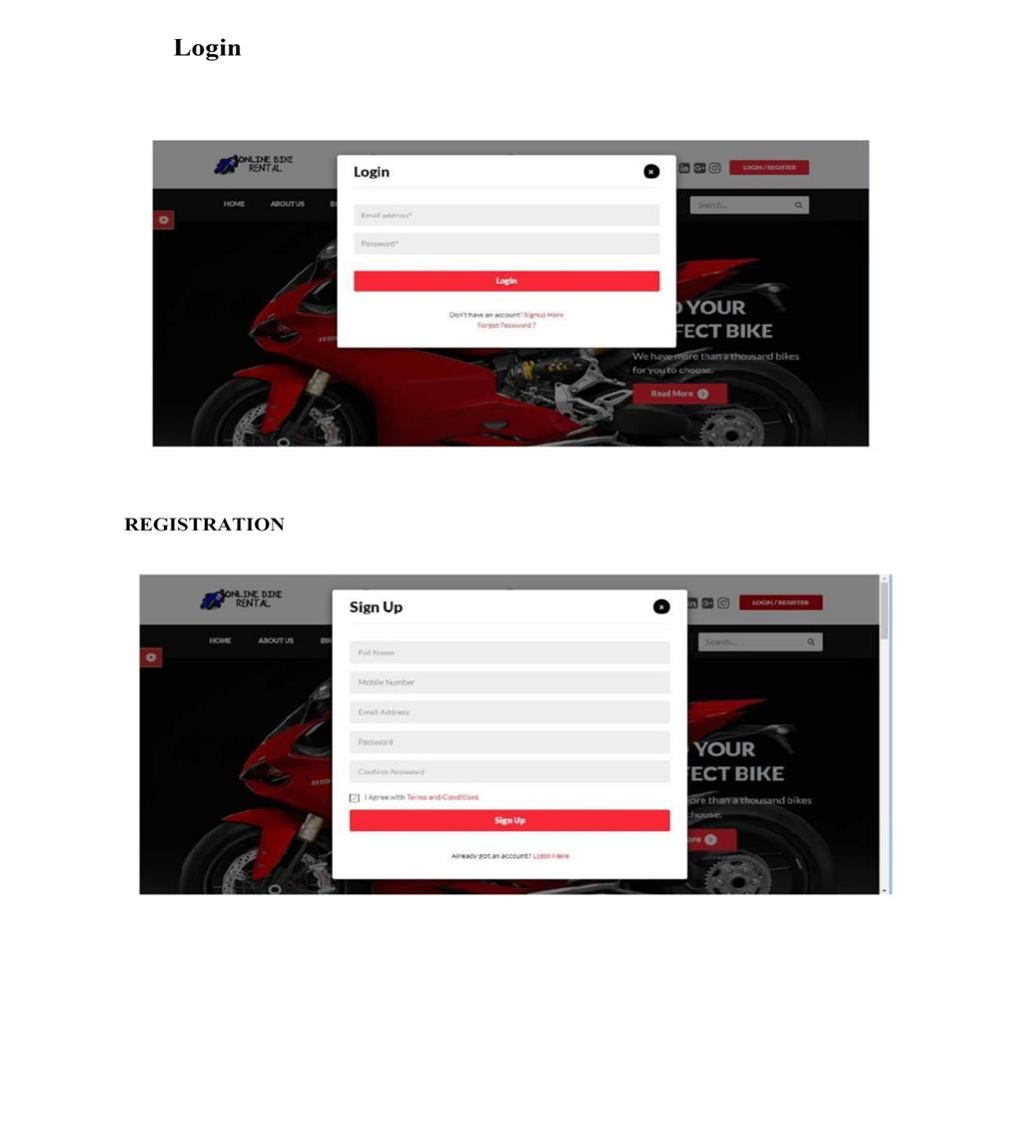

**LOGIN PAGE**

## E. SAMPLE OUTPUT

